Cybercrime Network Simulation using Cisco Packet Tracer
Author: Shubham Bhatti
Project Goal: Design and configure a small LAN representing a cybercrime investigation office using Cisco Packet Tracer.

Project Overview
This project simulates a small cybercrime investigation office. It contains one Cisco 1841 router, one Cisco 2960 switch, four investigator PCs and one evidence server. The router was configured with a static IP address (192.168.10.1/24), the interface was enabled using the 'no shutdown' command, and each host was assigned a static IP address.

Network Design
Device | IP Address
Router | 192.168.10.1
Investigator-PC1 | 192.168.10.10
Investigator-PC2 | 192.168.10.11
Investigator-PC3 | 192.168.10.12
Investigator-PC4 | 192.168.10.13
Evidence Server | 192.168.10.100

Configuration Summary
- Configured FastEthernet0/0 on the router.
- Assigned static IP addresses to all hosts.
- Configured default gateway as 192.168.10.1.
- Verified connectivity using the ping command.

Results and Analysis
The final ping test demonstrates successful communication between hosts and the router, showing that the LAN configuration is functioning correctly. During testing, initial connectivity issues were resolved by assigning correct IP addresses and default gateways. This troubleshooting process improved understanding of routing and host configuration.

Project Screenshots

Network Topology
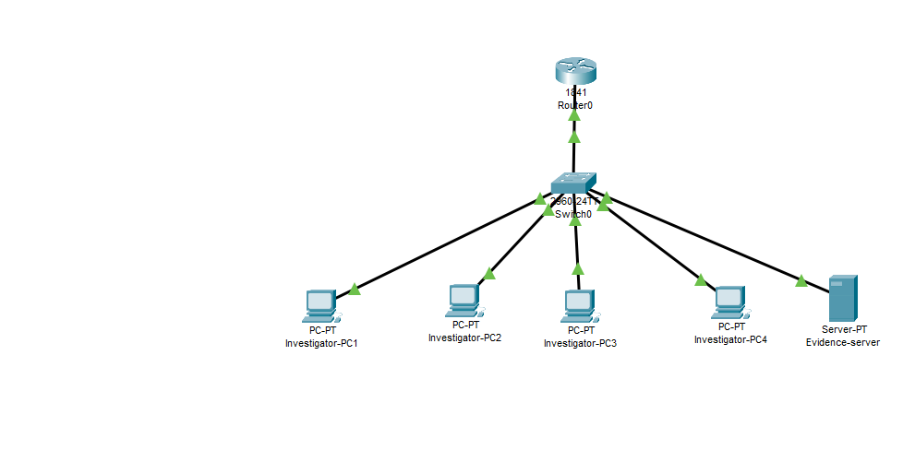

Router CLI Configuration
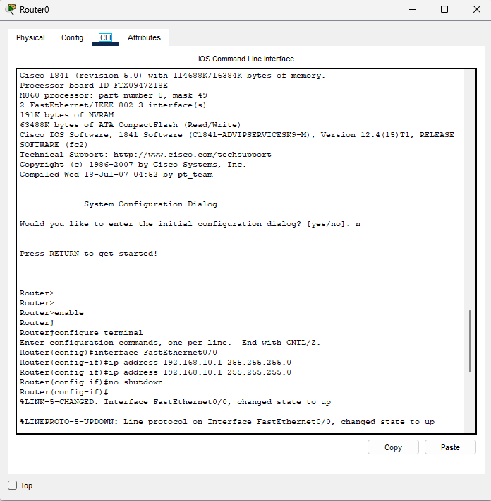

Final Successful Ping Test
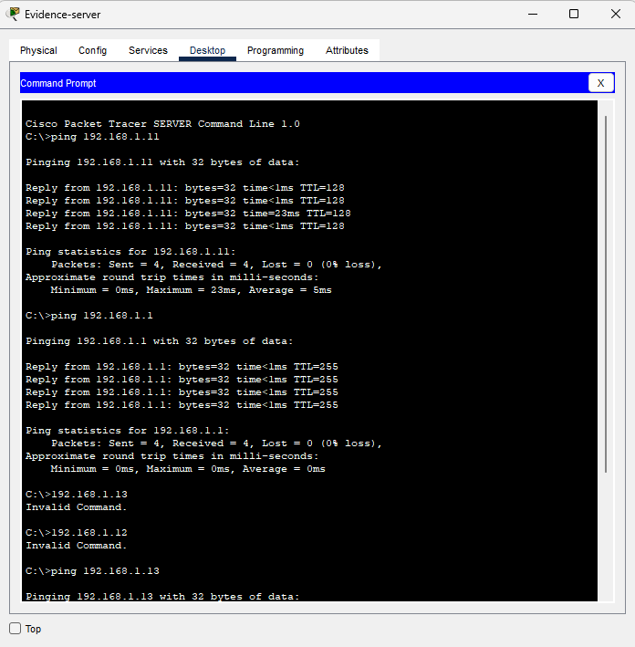

Skills Learned
• Cisco CLI
• Static IP Addressing
• Router and Switch Configuration
• Network Connectivity Testing
• Basic Troubleshooting
• Documentation

Future Improvements
Implement VLANs, DHCP, ACLs and SSH-based remote management to make the network more secure and scalable.

